Final Year Project

Attendance Monitoring

Joseph Friend

Introduction

The idea of my project is to remove the need for room attendance checkers and calculate the attendance of a room in real time as well as over time. It will also solve the problem of knowing where people are in your building.

The aim of my project is to use simple sensors to detect people in rooms. I will use embedded hardware. Through working on this project I will gain knowledge about how people move from place to place, gain ideas on flow and traffic, which could be used for car traffic. The device will be small and low powered.

Firstly I will research about why we really need attendance and how people have gathered this data over time. I will then explain how people in the past have used this data and what I will do with the data after I’ve collected it.

Secondly I will research into hardware and sensors, this gave me a gauge of the possibilities and limitations on my project.

I will also look into how the data I have collected can be shown and go through extra research that I thought could be valid when doing my project.

My system will be designed to be simple and relatively effective, however I won’t try to compete or attempt to be accurate as a RFID or facial recognition/video based system. I aim to come somewhere between using 30 weight sensors on each chair and have a live video stream of a classroom.

Research

2.1.1 How attendance is gathered?

I started my research on my project with looking into how attendance is gathered, the first time anyone discovers attendance is either by a teacher calling out names and a person says ‘yes’ or ‘here’, the next comes at secondary or further education with writing your name and then passing the sheet on, both these methods of finding out attendance of a room are very slow and require each person to have a general understanding of what is going on. This data is usually inputted onto a paper based system meaning if you wanted a live or recent data it would need to be inputted into a digital system, all very slow.

Other faster ways of gathering a person count is to use RFID tags (Shelke, 2018), this solution is simple and accurate and doesn’t require the need for a secondary input stage. However this system lacks flexibility and for every person you want to count needs a RFID tag to scan and most importantly they still need to scan it on a device or host station.

Ways to get around actually scanning the individual id is by using a Bluetooth system (Lodha, 2015), this means that every time a student carries his/her card and is attending the lecture the entries will be entered into the database with the timestamp as the lecturer moves around the class and the application detects the tags (these can be various devices such as mobile phones or student id cards). Also, the application is configured to detect tags only within a particular range in order to avoid detection of tags that are outside the class.

Another more advanced way of gathering attendance is by using a facial recognition system (Sayeed, 2017), this is widely used for identifying and verifying an individual by using digital camera or a video camera from a video source. It is characterized as a system that functions accurately under various conditions and famous approaches for face recognition includes the formations of the face attributes such as the ears, eyebrows, eye, lips, nose and chin, and their three dimensional relationships. This solution is very effective and can provide accurate results however cost and privacy are reasons I wouldn’t use this approach.

Other approaches attendance gathering include this bird study (Rose, A.P.R. (2009), is uses a weight-triggered electric switch attached to a perch. This system is waterproof and very simple and affordable. This system shows that sometimes you don’t need high tech equipment to gather all the information you need.

2.1.2 Why we want to know attendance?

There are many reasons we need to gather attendance, some of these reasons vary between person to person. A fire marshal may want to know how many people are in certain areas at certain times to know where there may be a bottle necks of people if a fire happened at certain places. (Thompson and Marchant, 2018) says most evacuation models are based on network-node models, this assigns all people in a room a 'node' the same walking speed, based upon the occupant density in that room, this means that if the occupancy value (density) can be calculated more accurately then the flow of people could be adjusted or better known.

A student lecture may want to see how many of his students are in what lectures and which labs are different times, there may be certain labs that are very busy and others that are quiet and if he allocated more lab space during that time it would be easy for the students to work. (Dey, 2018) says that class attendance has a positive and significant effect on standardized exam scores.

An employer in a large company may want to keep track of when his employees are at work and where they are spending their time. Things such as flexitime machines that log when you’re at but they don’t tell you that maybe you spend more time in certain area of the building talking to certain people, (Lee, Yang, and Lin, 2012) talk about methods that involve applying simulation to estimate the walking time of the occupant, and ant colony optimization algorithms to search for a near-optimal solution for the locations of the occupant flows. The derived solution can help occupants save walking time and achieve best operating efficiency.

2.1.3 How attendance can be displayed?

(Gupta, 2018) has a similar based system that I want to make, however he also has an LCD screen on the device to show people in the room the occupancy information. I hope to only allow people with certified access to know this information, people in the room won’t need to know this information because they’re in the room.

I have used a chart library in a previous project so I plan to use this to display the attendance in realtime. The static values will also be displayed in a table format.

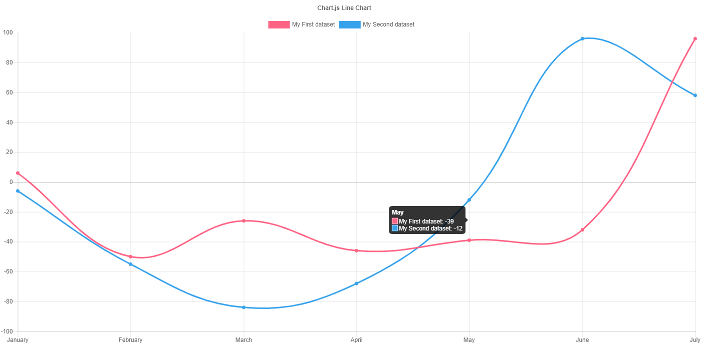

figure 1 chart.js example

I also hope to use heatmap.js overlayed over a map of a build to show where lots of people were during the course of time. See figure 1.1 below.

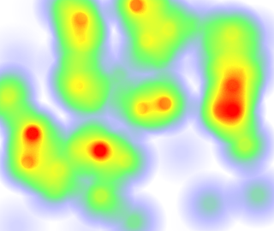

figure 1.1 heatmap.js example

2.3.1 Goals

By the end of my project I hope to have a device that counts the number of people in a room and then sends data to a server which then displays a page with charts and graphs of the data